Hello there! We are pleased to introduce you to our game “Last Hope”. You are part of NASA and we are about to save humanity by exploring Mars! You are our last chance, last hope!

Here are some bases of the game:

Start by dragging blocks from right rectangle to the left, where “Start_Program” button is located. You drag by clicking on a block and then moving your cursor while keeping the button pressed:

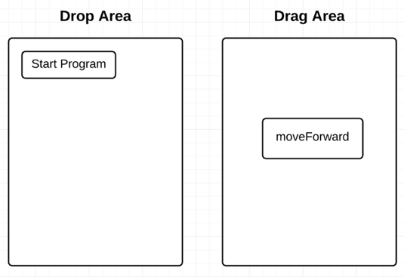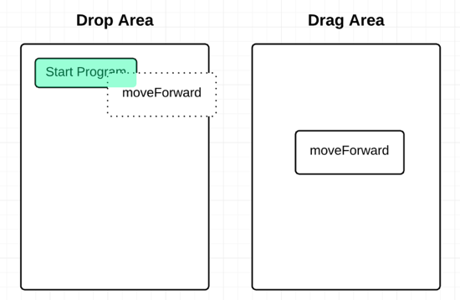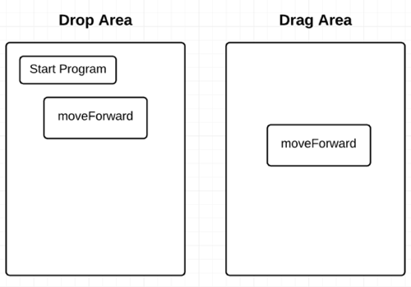

After you finished with dragging and dropping blocks, press “Run” button. It is located below “Drop Area”. This will execute the code you’ve written. Try it! And see the result!

P.S. Your mars explorer should move by one cell to the right. If you want to restart, press appearing “Restart” button. It should look like a snake going back.